**Set up guide**

This guide describes how to run this project on the windows PC.

**1.Install the MySQL database**

Download the MySQL Community version on mysql's website, get the MySQL Installer-Community.exe, and run the exe file.

Click add ... ->select custom->next

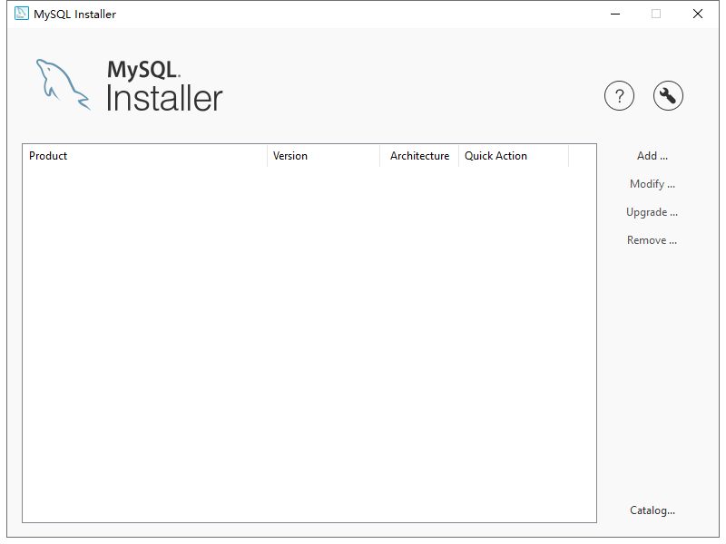 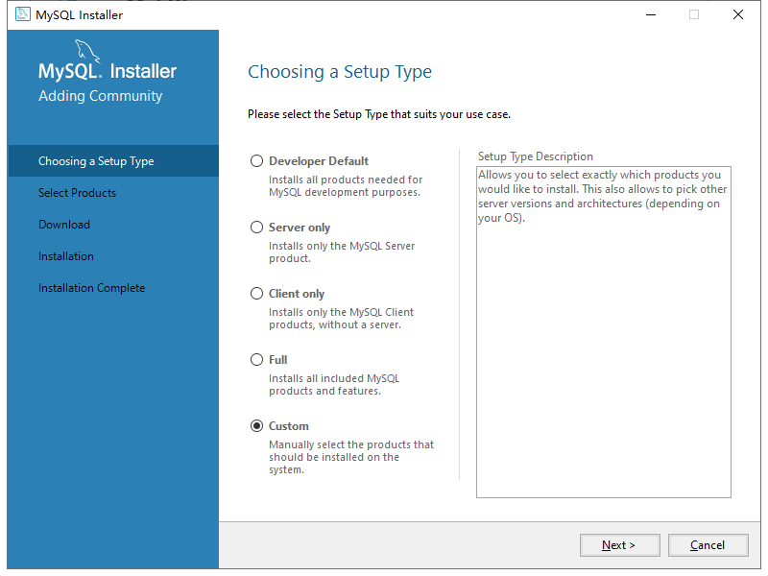

Add mySQLserver8.0 to the installation list- -> next

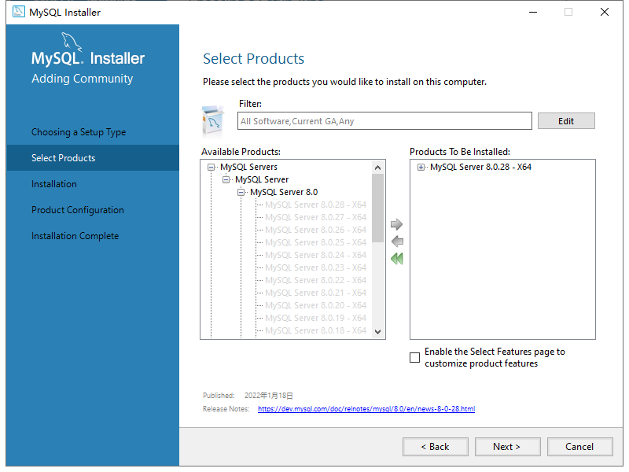

Continue to Click next until the page below-> select below (use Legacy version of the password)-> next->

Set the password to 234567891

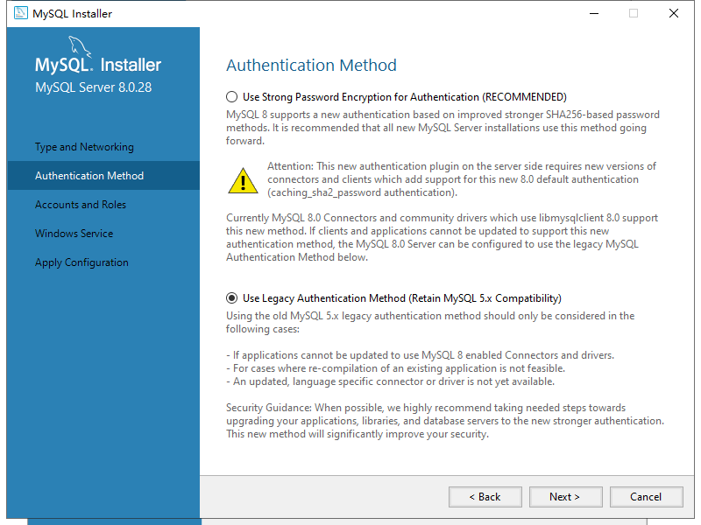

Continue with Click next until the end of this installation.

**2.Initialize the database data**

Create a database named sunlight in the database.

Run the SunLight.sql file in the Final Mysql DB in the command line in the sunlight database in the project.

**3.Run the project**

To simplify the set up process, here, use the ide to run the project without using the server

Download and install the WebStome.

Open WebStome->File-> Open opens the engineering folder.

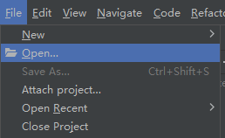 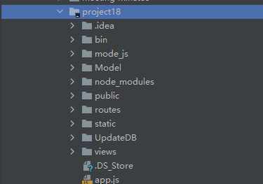

Click on the top right corner Edit Configurations.

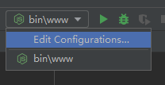

Select the node.Js for version 14.15.0. Click OK to save the configuration.

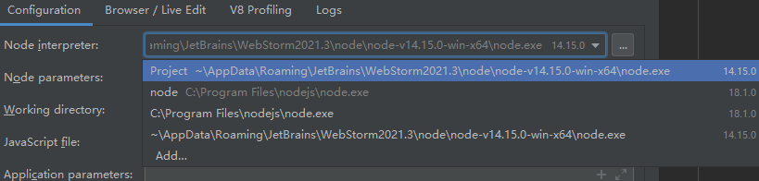

Click on the upper right Green triangle to run the project



If the output box reports no error, the project runs successfully.

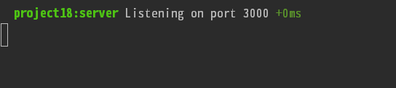

Enter http: / / localhost: 3000 to open the website.

